DATE AND TIME

1. Write a query to display the first day of the month (in datetime format) three months before the current month.

Ans:- SELECT DATE_FORMAT(SUBDATE(NOW(), INTERVAL 3 MONTH), '01/%m/%Y') AS LASTDATE;



1. Write a query to display the last day of the month (in datetime format) three months before the current month.

Ans:- SELECT DATE_FORMAT(LAST_DAY(SUBDATE(NOW(), INTERVAL 3 MONTH)), '%d/%m/%Y') AS LASTDATE;

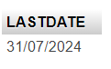

1. Write a query to get the distinct Mondays from hire_date in employees tables.

Ans:- SELECT E.FIRST_NAME, DAYNAME(E.HIRE_DATE) AS HIREDAY FROM employees AS E WHERE DAYNAME(E.HIRE_DATE)='MONDAY';

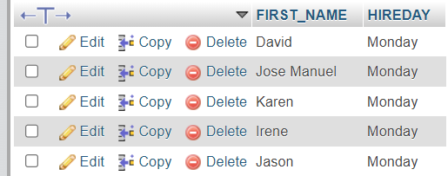

1. Write a query to get the first day of the current year.

Ans:- SELECT DATE_FORMAT(NOW(), '01/01/%Y');



1. Write a query to get the last day of the current year.

Ans:- SELECT DATE_FORMAT(NOW(), '31/12/%Y') AS LASTDAY;



1. Write a query to calculate the age in year.

Ans:- SELECT YEAR(NOW()) - YEAR('2005/06/06') AS AGE;



1. Write a query to get the current date in the following format.

Ans:- SELECT DATE_FORMAT(NOW(), '%M %d %Y') AS DATE;



1. Write a query to get the current date in Thursday September 2014 format.  
   Thursday September 2014

Ans:- SELECT DATE_FORMAT(NOW(), '%W %M %Y') AS DATE;



1. Write a query to extract the year from the current date.

Ans:- SELECT YEAR(NOW()) AS YEAR;



1. Write a query to get the DATE value from a given day (number in N).

Ans:- SELECT FROM_DAYS(730677);



1. Write a query to get the first name and hire date from employees table where hire date between '1987-06-01' and '1987-07-30'

Ans:- SELECT E.FIRST_NAME, E.HIRE_DATE FROM employees AS E WHERE E.HIRE_DATE BETWEEN '1987-06-01' AND '1987-07-30';

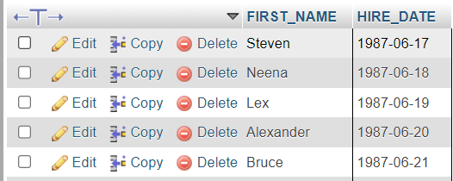

1. Write a query to display the current date in th14e following format.

Ans:- SELECT DATE_FORMAT(NOW(), '%W %D %M %Y %H:%i:%s') AS DATE;



1. Write a query to display the current date in the following format.

Ans:- SELECT DATE_FORMAT(NOW(), '%d/%m/%Y') AS DATE;



1. Write a query to display the current date in the following format.

Ans:- SELECT DATE_FORMAT(NOW(), '%i:%s %p %a %c, %Y') AS DATE;



1. Write a query to get the firstname, lastname who joined in the month of June.

Ans:- SELECT E.FIRST_NAME, E.LAST_NAME, E.HIRE_DATE FROM employees AS E WHERE DATE_FORMAT(E.HIRE_DATE, '%b') = 'Jun';

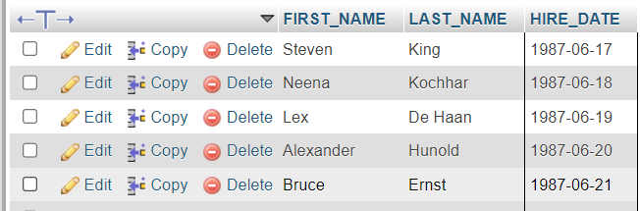

1. Write a query to get the years in which more than 10 employees joined.

Ans:- SELECT YEAR(E.HIRE_DATE), COUNT(*) FROM employees AS E GROUP BY YEAR(E.HIRE_DATE) HAVING COUNT(*)>10;



1. Write a query to get first name of employees who joined in 1987.

Ans:- SELECT E.FIRST_NAME FROM employees AS E WHERE YEAR(E.HIRE_DATE) = '1987%i';

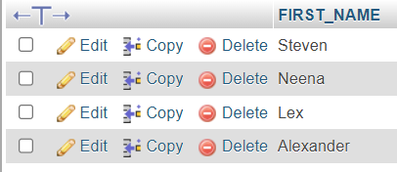

1. Write a query to get department name, manager name, and salary of the manager for all managers whose experience is more than 5 years.

Ans:- SELECT DEPARTMENT_NAME, FIRST_NAME, SALARY FROM departments D JOIN employees E ON (D.MANAGER_ID=E.MANAGER_ID) WHERE (SYSDATE()-HIRE_DATE) / 365 > 5;

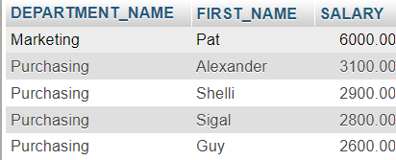

1. Write a query to get employee ID, last name, and date of first salary of the employees.

Ans:- SELECT E.EMPLOYEE_ID, E.LAST_NAME, E.HIRE_DATE, LAST_DAY(E.HIRE_DATE) AS DATE FROM employees AS E;

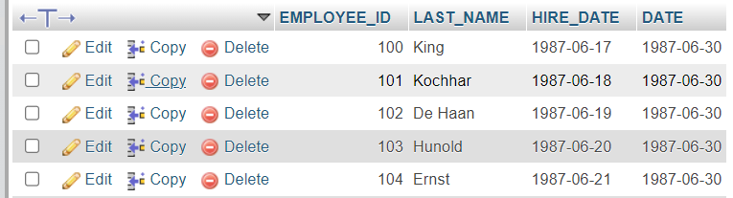

1. Write a query to get first name, hire date and experience of the employees.

Ans:- SELECT E.FIRST_NAME,YEAR(NOW()) - YEAR(E.HIRE_DATE) AS DIFF FROM employees AS E;

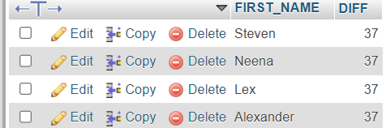

1. Write a query to get the department ID, year, and number of employees joined.

Ans:- SELECT E.DEPARTMENT_ID, YEAR(E.HIRE_DATE), COUNT(*) AS COUNT FROM employees AS E GROUP BY E.DEPARTMENT_ID, YEAR(E.HIRE_DATE);

